CUIMC MealPlan Install and Admin Guide

Table of Contents

Introduction 1

Navigating the Interface 1

The Administrative Module 1

Load Diners from File 2

Edit, View, and Add Diners 4

Selecting by UNI 5

Selecting from a List 6

Viewing a Diner 7

Editing a Diner 7

Adding a New Diner 9

View, Add, and Delete ID – UNI Links 10

Lookup a Single ID Card Number 11

View all ID – UNI Links 12

Add an ID – UNI Link by UNI 12

Add an ID – UNI Link from a List 14

Delete an ID – UNI Link 16

Reports 17

Summary Report 18

Transaction Log Detail 20

Daily Report 21

Database Maintenance 23

Backup Database 23

Clearing Data 25

Re-Building the Database 27

Acknowledgements 28

Installation and Setup 28

Technical Background 28

Download and Install Cygwin 29

Configure Cygwin and Install CUIMC MealPlan 29

Database Information 30

# Introduction

CUIMC MealPlan (MP) is a system to assist Faculty Club in administering diner check-in in the student dining plan. It is composed to two modules, a staff module for checking-in diners, and an administrative module for reporting and database maintenance.

# Navigating the Interface

The User Interfaces of CUIMC MealPlan are based on the UNIX *dialog* command. These interfaces, while mouse-aware, are designed to be used from the keyboard.

In general, the arrow keys will move the cursor around on the screen. If OK is highlighted, press Enter to select the highlighted option and continue. To CANCEL out of a menu and go back, use the Tab key until Cancel is highlighted, and then press enter. The Esc key will also cancel out of most screens.

Yes/No boxes work the same way. Yes is the default, so pressing Enter selects Yes. To select No, either Tab to it and press Enter, or press Esc.

When using Radio Button and Check Boxes, use the arrow keys to navigate the list and then press Space to select or deselect an option. Note that you MUST use space to select an option. Moving to an option and pressing Enter will not select that option before continuing.

For the Calendar widget, use the arrow keys to highlight the desired date, and then press Enter.

When using the card reader to input a card number, the reader automatically presses Enter for you.

By default, the all mouse clicks go to the application, which blocks copy and paste. To copy and paste, hold down the shift key, which will enable you to highlight desired text, or to right-click for a menu to copy and paste.

# The Administrative Module

To launch CUIMC MealPlan Admin (MPA), double-click on its icon



Upon startup of MPA, you will see the Main Menu.

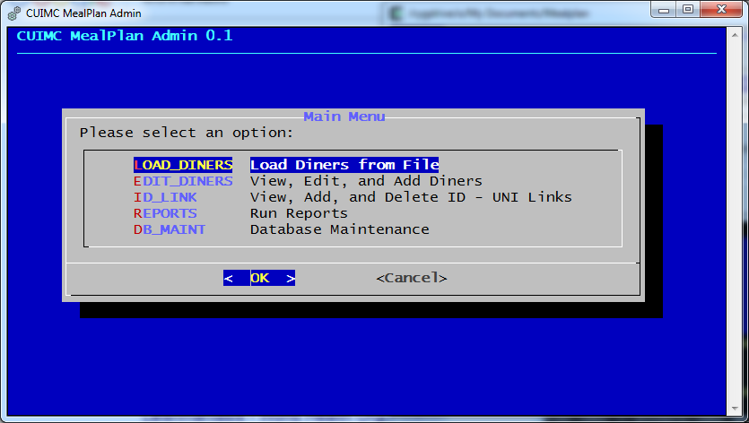

## Load Diners from File

To Load Diners from a File, select the LOAD_DINERS option. You will see a screen of information similar to the information below.

Diners are loaded from a CSV file that must be located in C:\Mealplan\Load. The first four columns of the CSV file must be Name, UNI, Affiliation, and Number of Meals. All other columns are ignored.

The Name field must be in “Lastname, Firstname” format.

If the UNI in a line is blank or does not have any numbers, it will be ignored. This will skip over header lines and blank lines.

If a UNI already exists in the database, the name, affiliation, and number of meals will be updated.

If using Microsoft Excel, save the file as “CSV (Comma Delimited)(*.csv)”. Do not use spaces in the filename. Remember that the file must be in Mealplan\Load for MPA to see it.[1]

Use PgUp and PgDn to scroll, and press Enter to continue.

If there are multiple CSV files in Mealplan\Load, you’ll see a list of them.

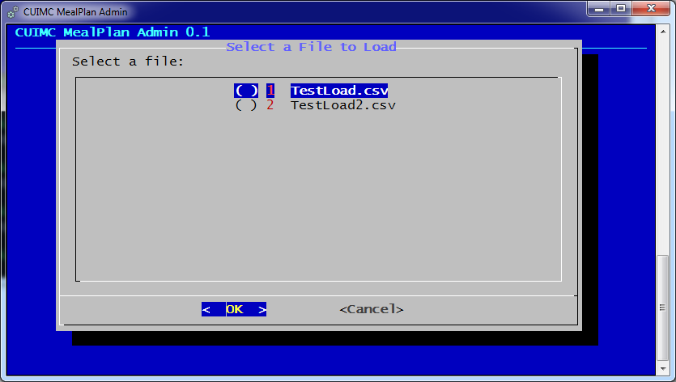

Use the arrow keys to select the file to be loaded, press space to select the file (an * will appear next to it), and then press Enter to continue. If there is only one file in Load, you will skip this step. If there are no CSV files, you will get an error.

MPA will display the first few lines of the file.

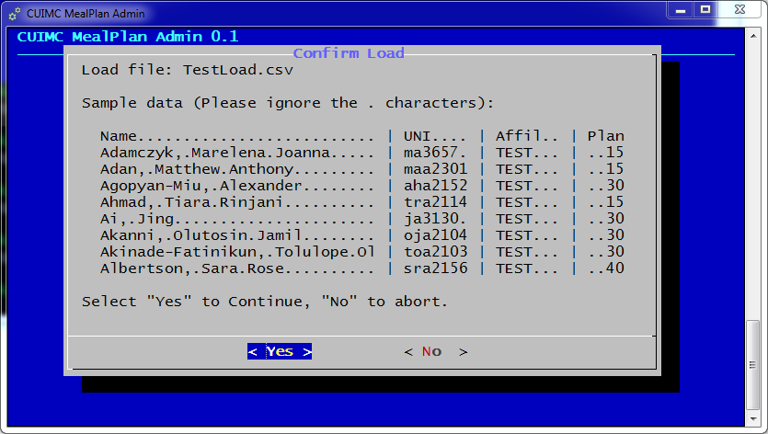

(The dots are to work around a bug in dialog. They will not be added to the database and can be ignored.)

Verify that the data looks correct, and then press Yes to load or No to abort.

The load will proceed quickly. MPA will provide status updates every 50 users, and then a final update.

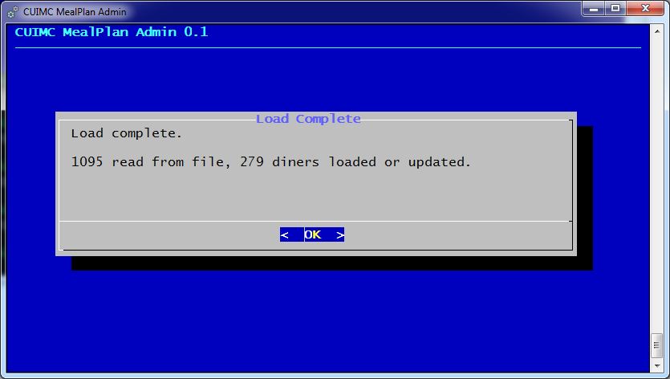

## Edit, View, and Add Diners

To Edit, View, or Add Diners, select EDIT_DINERS from the Main Menu.

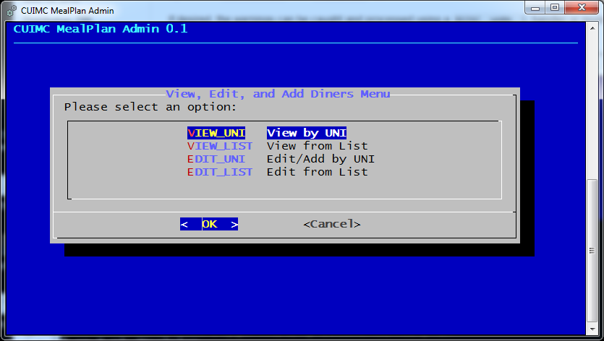

You may select users by directly inputting a UNI, or from a list.

### Selecting by UNI

When viewing or editing by UNI, MPA will ask for a UNI.

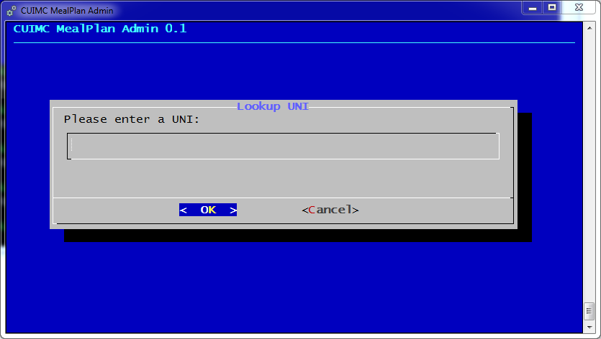

### Selecting from a List

When selecting from a list, MPA will display a list of ALL users in the database, in alphabetical order by name.

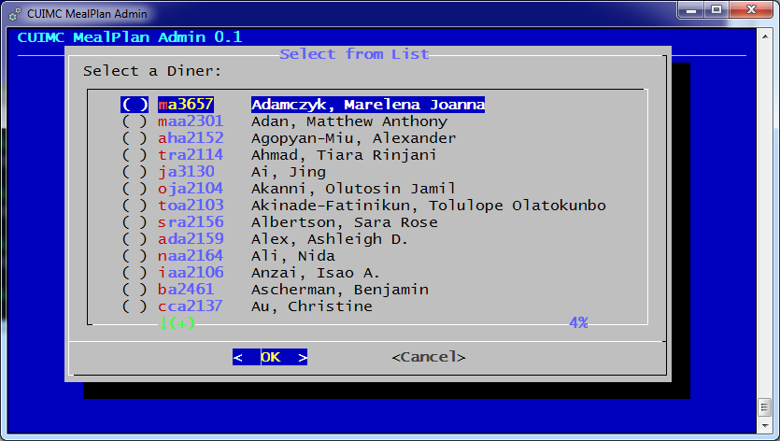

Use the arrow keys and PgUp/PgDn keys to navigate the list. Press space to select a diner (a * will appear next to the name).

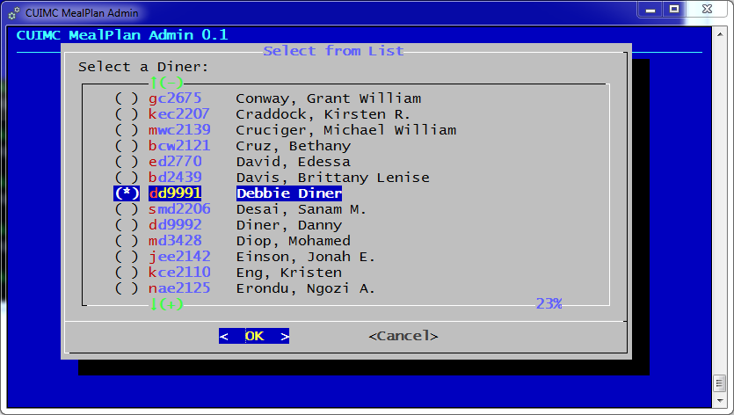

To continue, press Enter.

### Viewing a Diner

When viewing a diner, you will see the diner’s name, UNI, affiliation, current meal count, meal plan, ID Card assocations, and a list of all check-in dates and times. Use PgUp/PgDn to scroll.

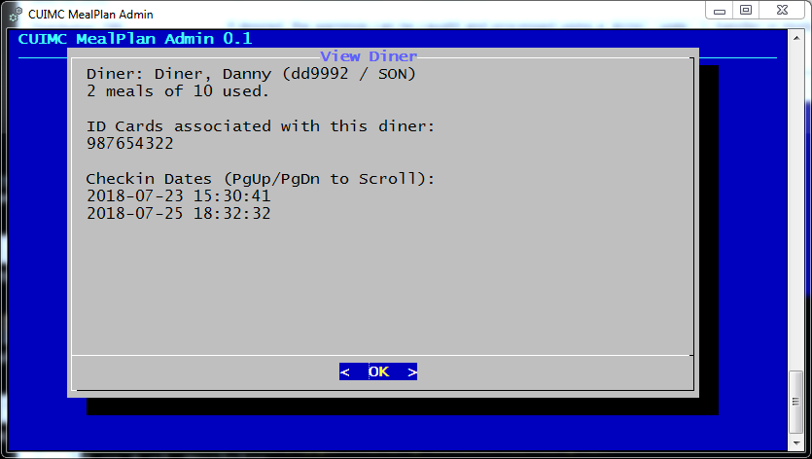

### Editing a Diner

When editing a diner, you will see the following screen.

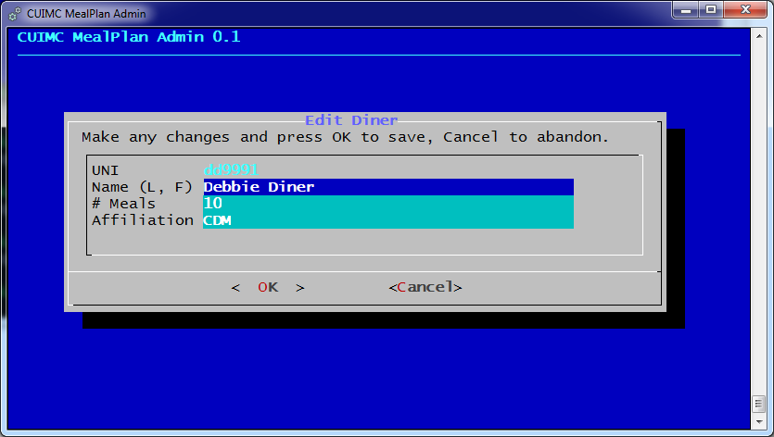

Use the arrow keys to move the cursor and to move between fields. You may not change the UNI. Note that Backspace will not work as you expect, but Delete will. Press Enter to save changes, or Cancel to abort.

If you do update, you will get a confirmation.

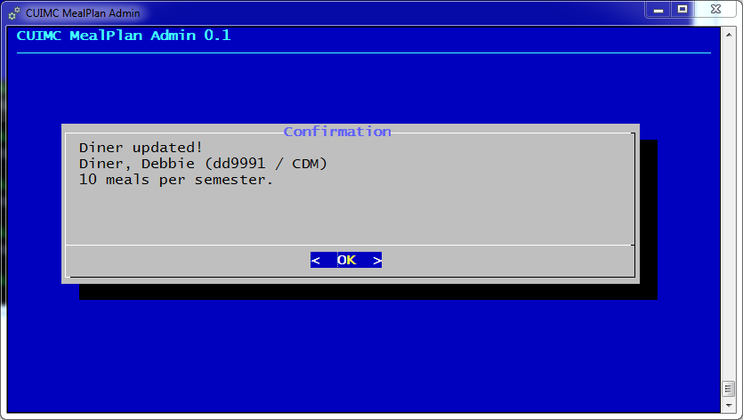

### Adding a New Diner

Note: To add multiple new diners, it is probably best to use the LOAD_DINERS option from the Main Menu. This is intended for adding one or two new diners.

From the “Edit, View, and Add Diners Menu”, select EDIT_UNI. In the Lookup UNI box, type the UNI of the new user. MPA will ask if you wish to add a new diner.

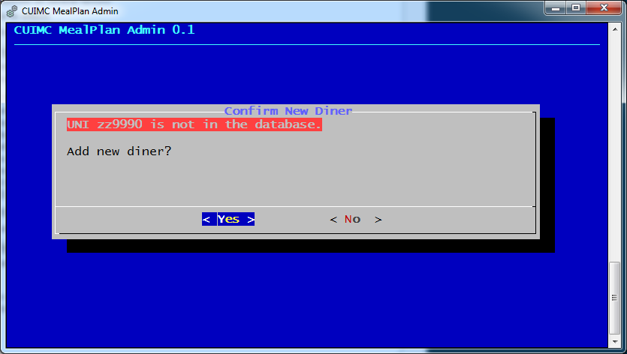

If you select Yes, you will get a blank Edit Diner form, with the UNI pre-filled.

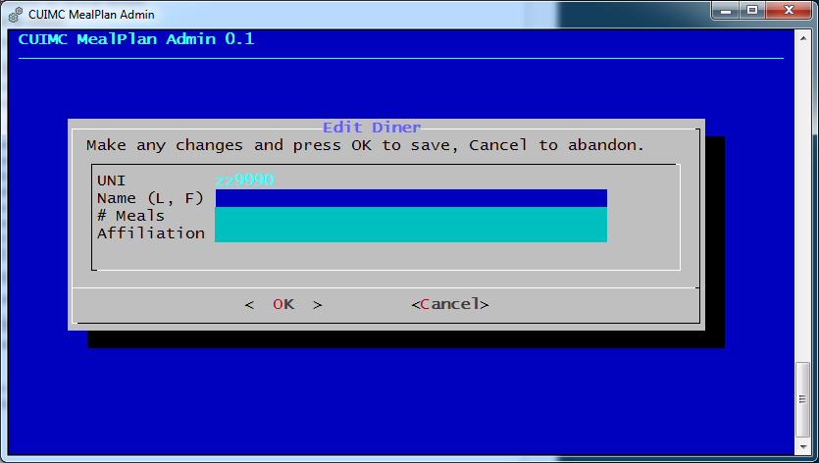

Fill in the information and select OK to save. You will get a confirmation.

## View, Add, and Delete ID – UNI Links

To View, Add, and Delete ID – UNI Links, select ID_LINK from the Main Menu.

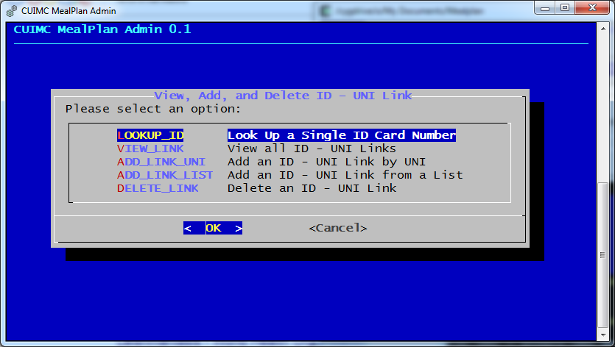

From the View, Add, and Delete ID – UNI Link menu, you can lookup a single card number, view all links, add an ID Card to a diner, or delete an ID Card from the database. (Note that you can also add links at the time of check-in.)

### Lookup a Single ID Card Number

To look up an ID Card number, select LOOKUP_UD from the menu.

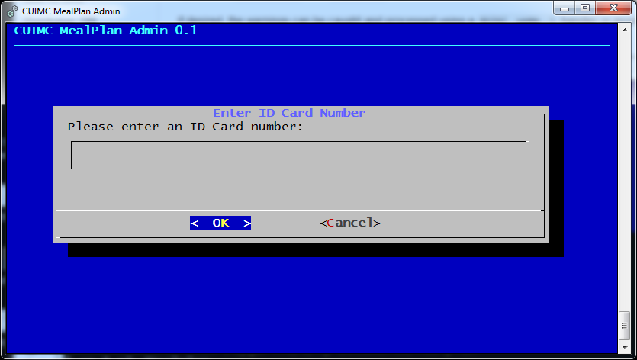

Type in the ID Card number you wish to search for. Remember that ID Card numbers are 9 numeric digits. Anything else will return an error.

If the ID Card exists in the database, you will see the name and UNI of the linked diner. Otherwise, you will get an error.

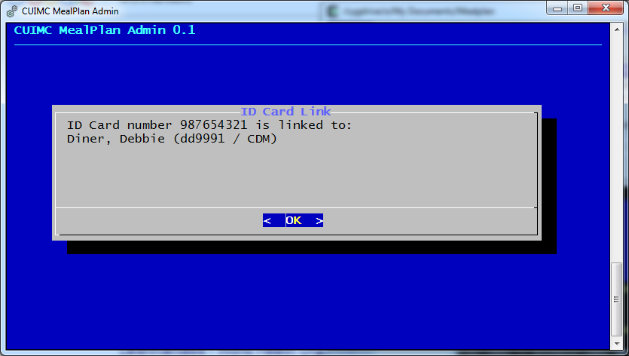

### View all ID – UNI Links

To view all ID – UNI Links, select VIEW_LINK from the menu.

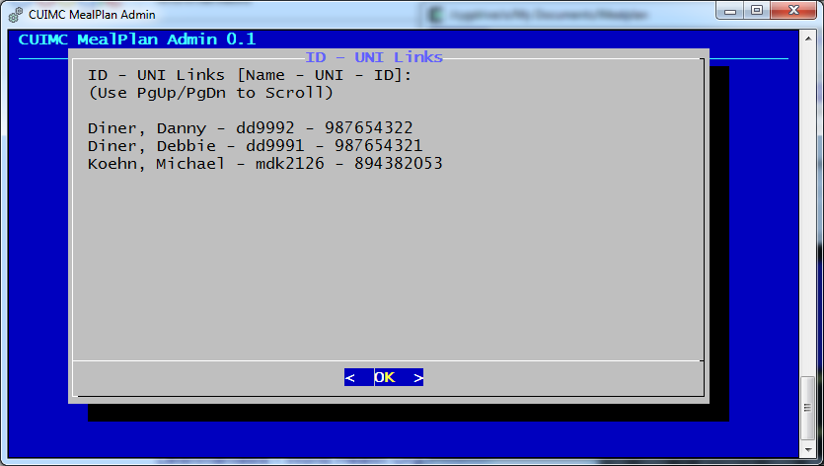

MPA will display all ID – UNI Links, sorted by diner name.

### Add an ID – UNI Link by UNI

To link an ID with a UNI by inputting the UNI, select ADD_LINK_UNI from the menu.

MPA will ask for a UNI and an ID Card number.

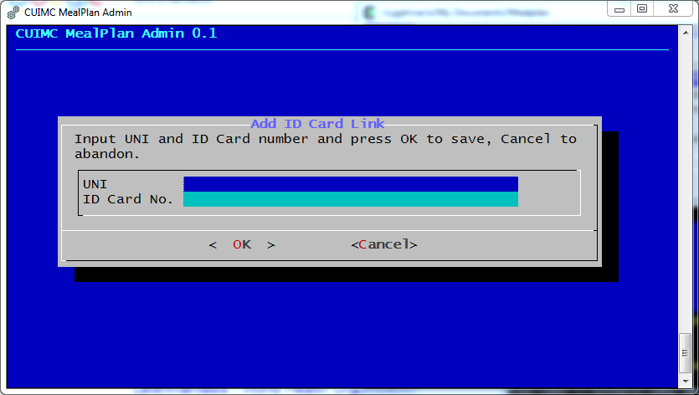

Input a UNI and an ID Card number and select OK to continue. WPA asks for a confirmation.

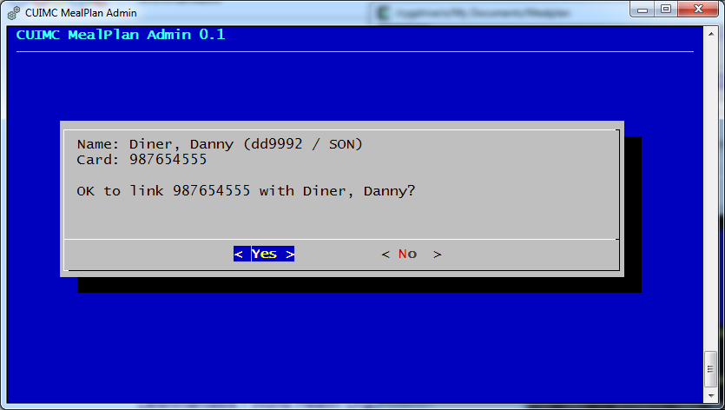

Select Yes to continue. If adding the link succeeds, you will get a confirmation of success. Otherwise, you will see an error message.

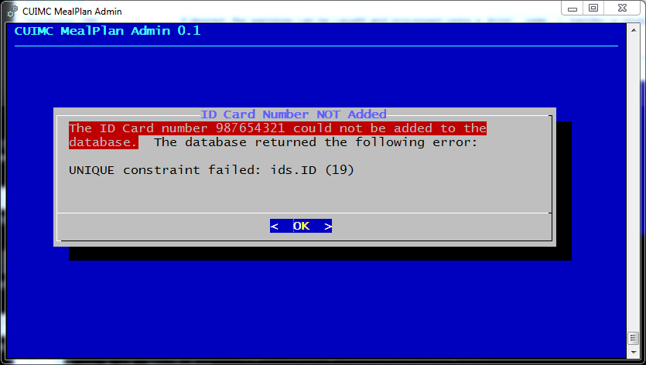

This is the most likely database error, and means that the ID Card number is already in the database.

### Add an ID – UNI Link from a List

To link an ID with a UNI by selecting a diner from a list, select ADD_LINK_LIST from the menu.

MPA will display a list of all users, in alphabetical order by name.

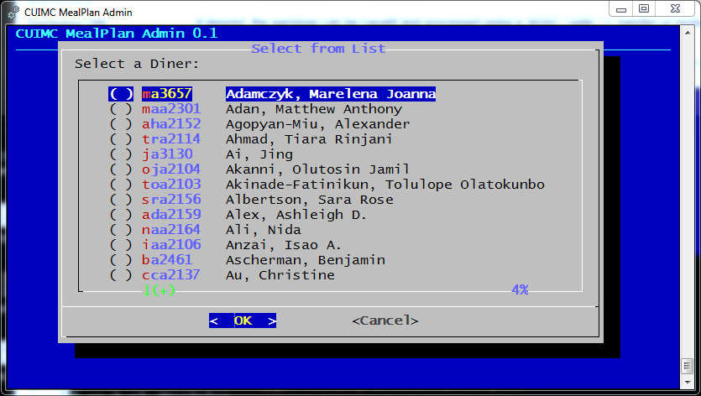

Find the diner you wish to add and ID association to, and press Space to put an * next to the name. Then, press Enter to continue.

MPA will ask for an ID Card number.

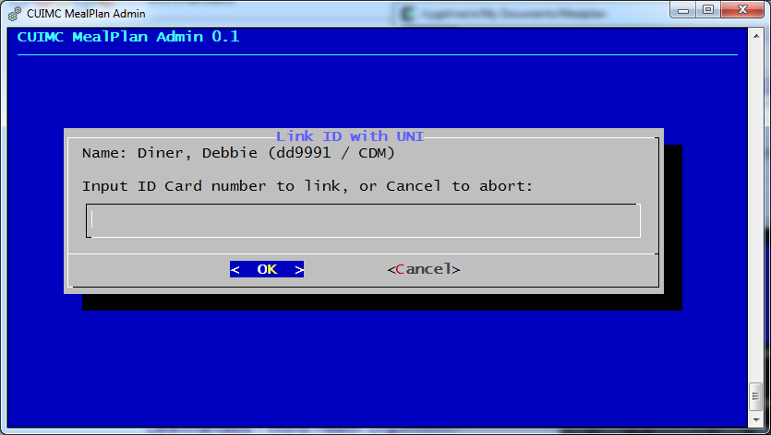

Remember that ID Card numbers are 9 numeric digits long. Anything else will result in an error.

If adding an association succeeds, you will get a confirmation of success. Otherwise, you will see an error message.



This is the most likely database error, and means that the ID Card number is already in the database.

### Delete an ID – UNI Link

To delete an ID – UNI Link, select DELETE_LINK from the menu.

MPA will ask for an ID Card Number. ID Card numbers are 9 numeric digits long. Anything else will return an error.

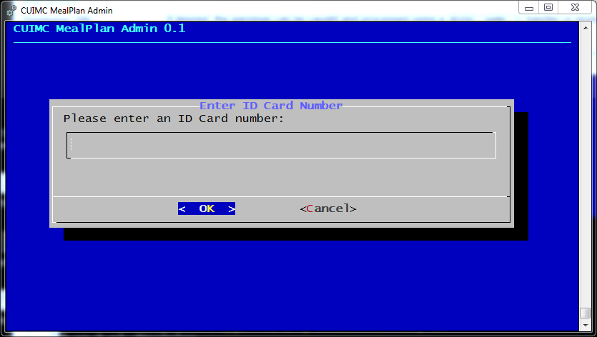

If the ID Card number is in the database, MPA will ask for confirmation to delete.

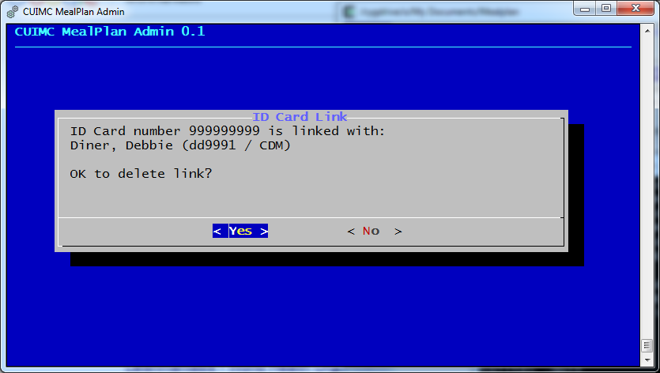

Select Yes to delete the association, or No to keep it. MPA will confirm your action.

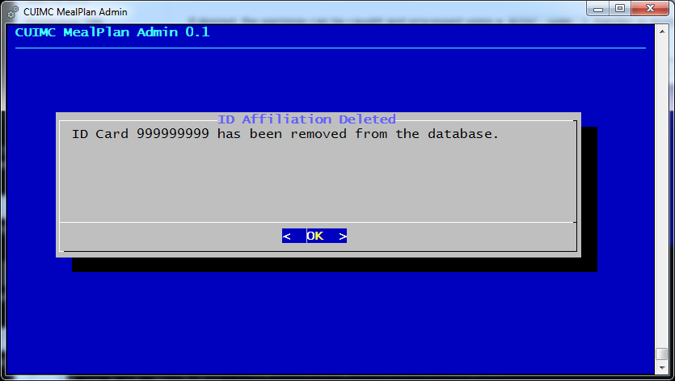

## Reports

The REPORTS option of the Main Menu allows you to run various reports on the MP database.

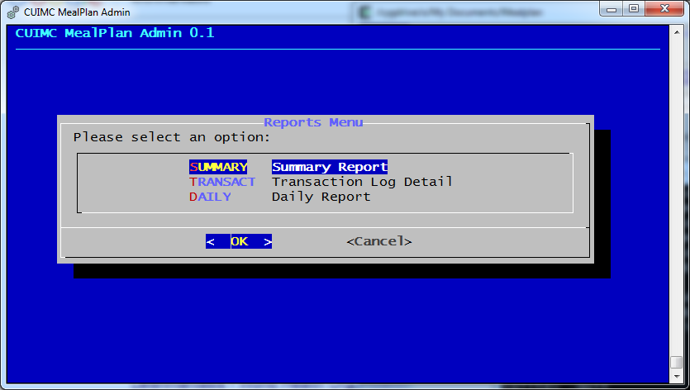

All reports are saved as CSV files in the Mealplan\Reports directory. Summary and Transaction Log reports are named for the date and time at which they are run, in the format YYYYMMDD-HHMMSS. Note that these are snapshot reports and always reflect the current state of the database.

The Daily report is run for a specified date, and named accordingly, YYYYMMDD.

### Summary Report

The Summary Report lists all diners in the database and the number of meals used to date. To run this report, select SUMMARY from the menu. WPA asks for confirmation.

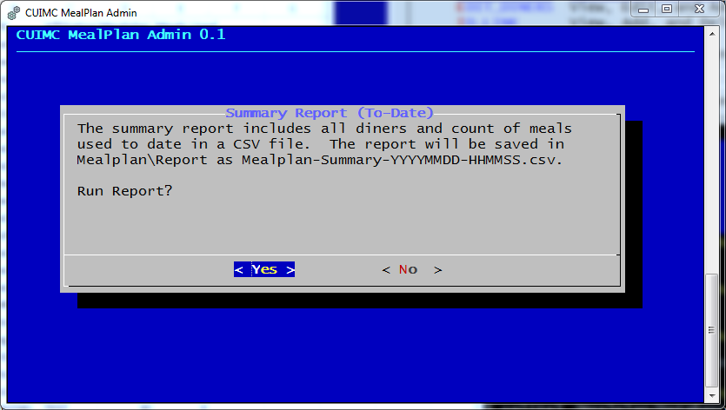

If you select Yes to continue, WPA will run the report and acknowledge completion.

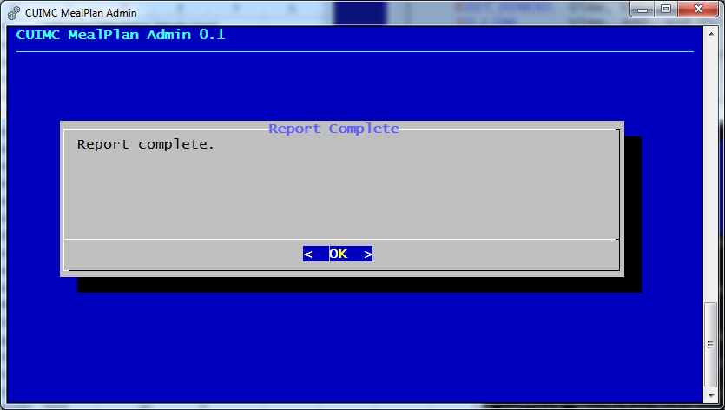

Here’s an example of the output, loaded into Microsoft Excel.

|  |  |  |  |  |
| --- | --- | --- | --- | --- |
| Name | UNI | Affiliation | Mealplan | Meals Used |
| Colbert, Allen | abc123 | Central | 12 | 0 |
| Diner, Danny | dd9992 | SON | 10 | 1 |
| Diner, Debbie | dd9991 | CDM | 10 | 6 |
| Koehn, Michael | mdk2126 | GSAS | 4 | 4 |
| Michael Alberto | ma494 | P&S | 22 | 0 |

### Transaction Log Detail

The Transaction Log Detail report records every time that a diner has checked in to Mealplan. To run this report, select TRANSACT from the menu. WPA will ask for confirmation to run this report.

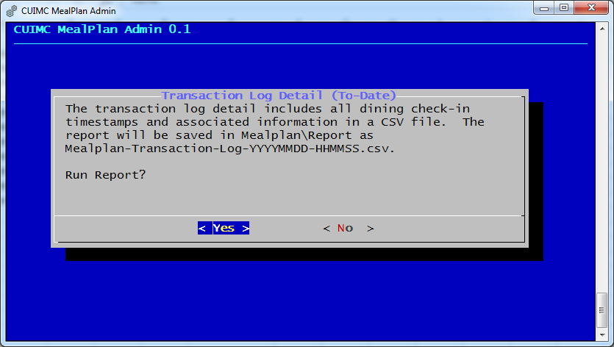

If you select Yes to continue, WPA will run the report and acknowledge completion.



Here’s an example of the output, loaded into Microsoft Excel.

|  |  |  |  |  |
| --- | --- | --- | --- | --- |
| Name | UNI | Mealplan | Affiliation | Timestamp |
| Koehn, Michael | mdk2126 | 4 | GSAS | 1/11/2018 13:57 |
| Koehn, Michael | mdk2126 | 4 | GSAS | 1/11/2018 13:58 |
| Koehn, Michael | mdk2126 | 4 | GSAS | 1/11/2018 13:58 |
| Koehn, Michael | mdk2126 | 4 | GSAS | 1/11/2018 13:59 |
| Diner, Debbie | dd9991 | 10 | CDM | 7/19/2018 17:24 |
| Diner, Debbie | dd9991 | 10 | CDM | 7/19/2018 17:42 |
| Diner, Debbie | dd9991 | 10 | CDM | 7/23/2018 13:10 |
| Diner, Debbie | dd9991 | 10 | CDM | 7/23/2018 13:10 |
| Diner, Debbie | dd9991 | 10 | CDM | 7/23/2018 13:17 |
| Diner, Debbie | dd9991 | 10 | CDM | 7/23/2018 13:23 |
| Diner, Danny | dd9992 | 10 | SON | 7/23/2018 15:30 |

### Daily Report

The Daily Report provides the total number of check-ins on a given date as well as a list of all diners checking in and the number of times the diner checked in. To run the Daily Report, select DAILY from the menu.

WPA will ask for the reporting date.

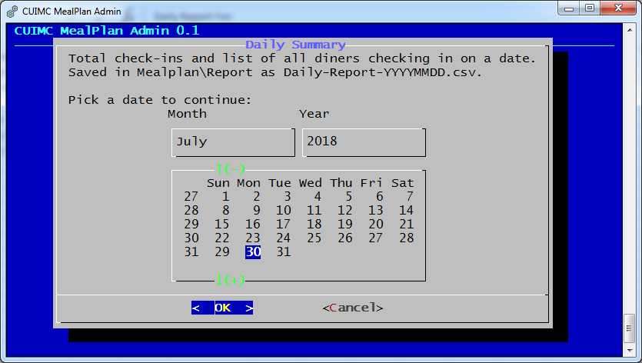

By default, today is selected. Use the arrow keys to move around on the calendar. (Ignore the extra numbers on the left. They seem to do no harm, and you cannot select them.) Press enter to select a date.

WPA will run the report and acknowledge completion.



Here’s an example of the output, loaded into Microsoft Excel.

|  |  |  |  |  |  |
| --- | --- | --- | --- | --- | --- |
| Daily Report For: | 7/23/2018 |  |  |  |  |
| Report Run Time: | Tue Jul 24 09:00:20 2018 | | |  |  |
| Total Meals: | 5 |  |  |  |  |
|  |  |  |  |  |  |
| Name | UNI | Mealplan | Affiliation | Timestamp | # Check-ins |
| Diner, Danny | dd9992 | 10 | SON | 7/23/2018 15:30 | 1 |
| Diner, Debbie | dd9991 | 10 | CDM | 7/23/2018 13:23 | 4 |

The top line is the report date, selected from the calendar. The second line is the date and time on which the report was run. The third line is the total number of meals for the day. The report detail begins on line 5.

## Database Maintenance

The DB_MAINT option on the Main Menu has three sub-options, BACKUP, CLEAR, and REBUILD.

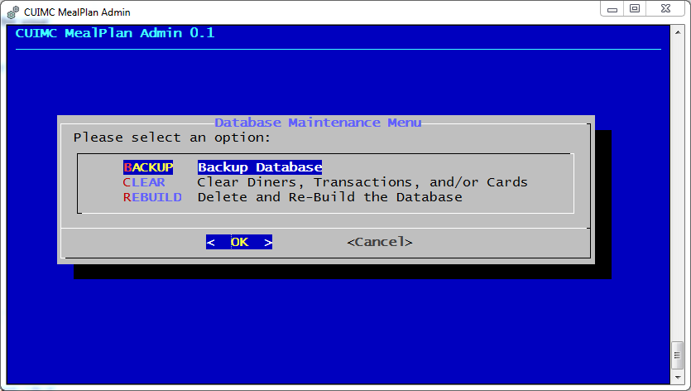

Backup will create a backup of the entire MP database. Clear will delete all entries from selected tables. Rebuild will delete all contents of the database and create fresh tables.

### Backup Database

To backup the database, begin by selecting BACKUP from the Database Maintenance Menu. MPA will confirm that you want to back up.

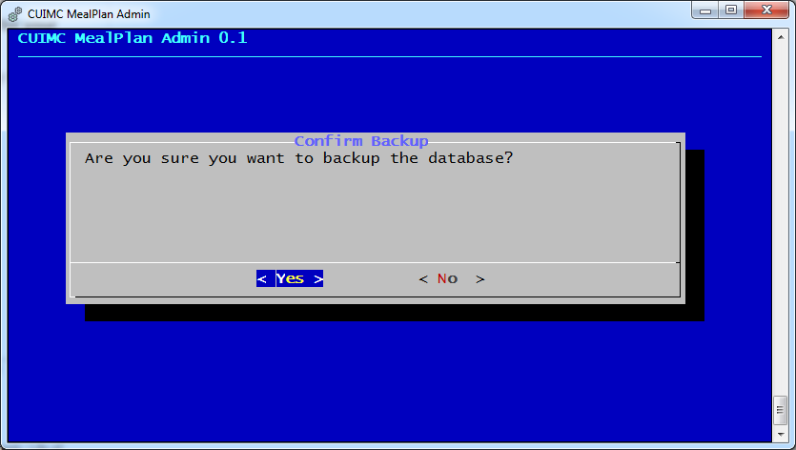

If you select Yes, the backup will proceed and in a few seconds you will get a confirmation screen.

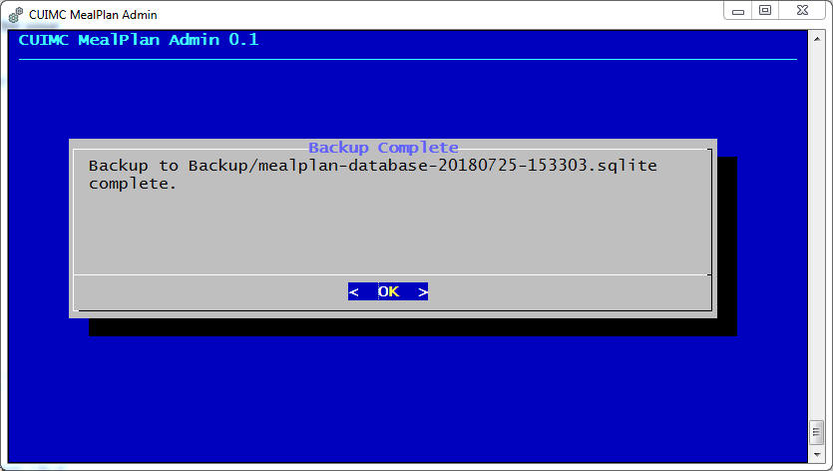

Note that backups are always stored in C:\Mealplan\Backup. They are named by the date and time created, in the format YYYYMMDD-HHMMSS.

This is still a SQLite database file. You can restore it by copying it to C:\Mealplan\Database, renaming or deleting the existing mealplan.sqlite, and renaming the backup file to mealplan.sqlite.

### Clearing Data

At the end of the semester, it is best to clear diners and check-in records. ID Cards can be carried from one semester to another, but should be purged on occasion.

It is STRONGLY RECOMMENDED that you backup the database before you clear it. Clearing cannot be undone. You may also want to run final reports.

To clear data, select CLEAR from the Database Maintenance Menu. MPA will allow you to select one or more databases to clear.

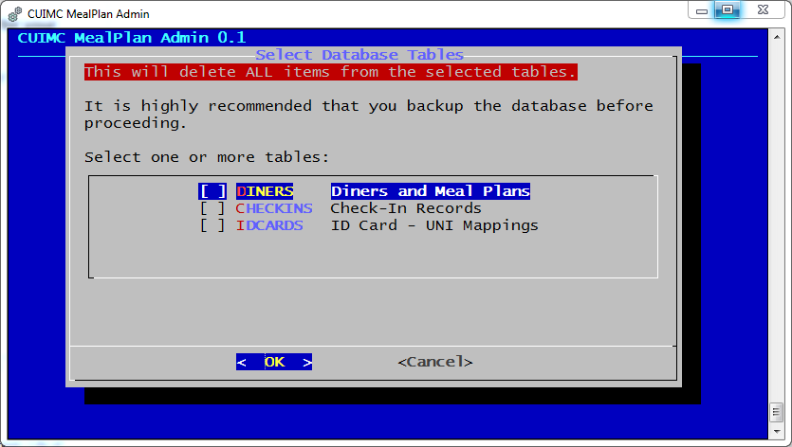

Use the arrow keys to move the cursor, and press space to select a database. You may select multiple databases to clear. When ready to proceed, press Enter.

MPA will display a confirmation screen.

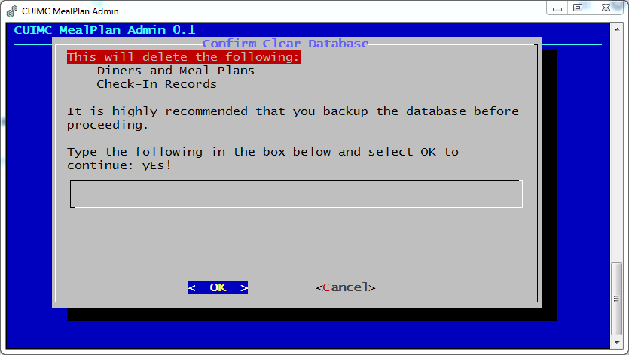

Confirm that the selected tables are listed. To proceed, you must type “yEs!” (no quotes) exactly and press enter. “Yes”, “YES”, “yes”, and the like will not work. ONLY “yEs!” will work.

Press Enter to continue, or select Cancel to abort and return to the Maintenance menu.

If you continue, data will be deleted from the tables and the database will be compacted to free space. Then you will get a confirmation message.

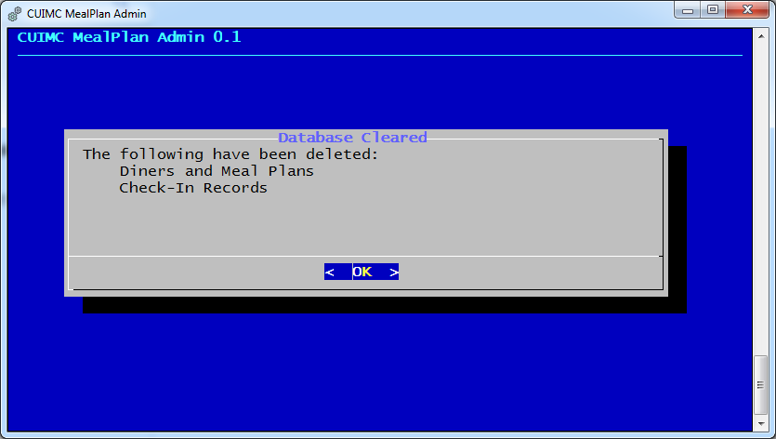

### Re-Building the Database

On the Database Maintenance Menu, REBUILD will delete all three MP tables – diners, ids, and checkin – and re-create them.

This will remove all MP-related data from the database and cannot be undone. It is STRONGLY RECOMMENDED that you backup your database before you REBUILD.

To begin, select REBUILD from the Maintenance menu. MPA will display a confirmation screen.

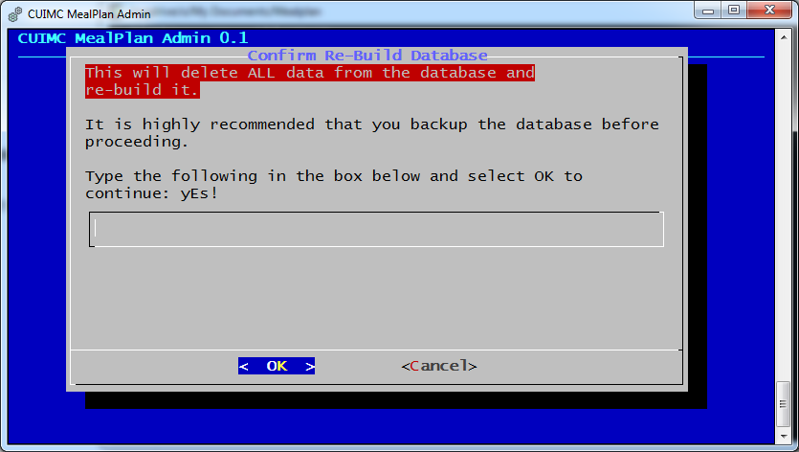

Confirm that you want to rebuild the database. To proceed, you must type “yEs!” (no quotes) exactly and press enter. “Yes”, “YES”, “yes”, and the like will not work. ONLY “yEs!” will work.

Rebuild is quick, and you will see a confirmation in a few seconds.

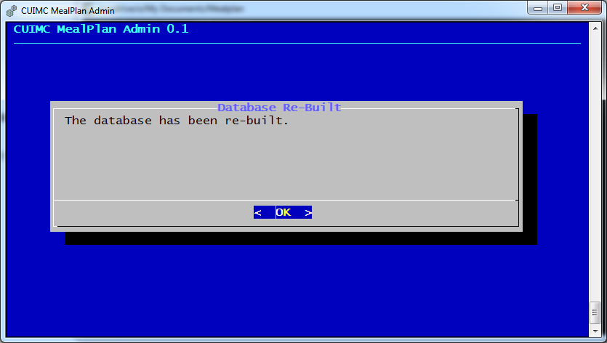

# Acknowledgements

This project would not have been possible without the work of many others in the Free Software and Open Source Software world.

Perl programming language – <https://www.perl.org/>

Perl DBI – <https://dbi.perl.org/>

Cygwin project – <https://www.cygwin.com/>

SQLite – <https://www.sqlite.org/>

dialog (AKA cdialog) – <http://invisible-island.net/dialog/>

UI::Dialog Perl module by Kevin C. Krinke

The program icons are by BomSymbols (<https://creativemarket.com/BomSymbols>) and are free for non-commercial use.

# Installation and Setup

## Technical Background

MP is written in Perl, and uses the *dialog* program, found on most UNIX and Linux systems, for user interface. The database is SQLite.

MP should run on most common UNIX-like environments, including Cygwin on Microsoft Windows. The installation instructions below are for Cygwin.

## Download and Install Cygwin

1. Download the Cygwin installer appropriate for your version of Windows from <https://www.cygwin.com/>
2. Run the downloaded installer. DO NOT run as administrator (it will cause problems later). If it insists on running as administrator, pass the --no-admin command line option.
3. In the Wizard, make the following choices:
   1. Install for “Just Me” rather than “All Users”.
   2. When selecting a Download Site, http://mirror.cs.vt.edu is a good option.
   3. In “Select Packages”, ADD the following packages:
      1. perl: Perl programming language interpreter (in Perl);
      2. perl-DBD-SQLite: Perl distribution DBD-SQLite (in Perl);
      3. sqlite3: Client program for accessing SQLite3 databases, plus docs (in Database);
      4. curl: Multi-protocol file transfer tool (in Net);
      5. wget: Utility to retrieve files from WWW via HTTP and FTP (in Web);
      6. make: The GNU version of the ‘make’ utility (in Devel);
      7. gcc-core: GNU Compiler Collection (C, OpenMP) (in Devel);
      8. clang: C/C++ compiler frontend based on LLVM (in Devel);
      9. vim: Vi IMproved – enhanced vi editor (in Editors);
      10. nano: Enhanced clone of Pico editor (in Editors); and
      11. dialog: Curses widget-based script interpreter (in Interpreters).
   4. Download and installation will take some time. Please be patient.
   5. Icons and Start Menu entries are optional. Start menu is recommended.

## Configure Cygwin and Install CUIMC MealPlan

1. Run a Cygwin terminal. If you installed Icons, it will be on the desktop. Otherwise, use the Start menu. Run the following commands to install CPANminus and UI::Dialog, both Perl add-ons. (If you get odd errors about *local::lib*, you probably installed Cygwin as administrator. It’s fixable, but I leave it as an exercise for the reader.)
   1. cpan App::cpanminus
   2. cpanm UI::Dialog
   3. cpanm Text::CSV
2. Unzip the install .zip file in C:\. It should create a Mealplan directory with the following content:
   1. mealplan.pl and mealplanadmin.pl;
   2. mealplan.sh and mealplanadmin.sh;
   3. mealplan.ico and mealplanadmin.ico;
   4. CUIMC MealPlan.lnk and CUIMC MealPlan Admin.lnk;
   5. Backup, Database, Load, and Report directories, all empty; and
   6. Docs directory, containing this file and user documentation.
3. In a Cygwin terminal, create a mount point.
   1. nano /etc/fstab
   2. Add the following line to the end of the file:

C:/Mealplan /Mealplan NTFS binary,posix=0,user

* 1. Ctrl-O to save
  2. Ctrl-X to exit

1. The two .lnk files are Desktop and Start Menu icons. Copy them to a convenient location for users.[2]
2. Double-click “CUIMC MealPlan Admin. You should see the following screen: 
3. Use the arrow keys to select DB_MAINT and press Enter. (Or, use the mouse to click DB_MAINT and click OK.)
4. Select REBUILD and press Enter.
5. Follow the prompts to establish a new database.

At this point, CUIMC MealPlan is ready to use, although the database is empty.

# Database Information

Currently, CUIMC MealPlan (MP) uses a local SQLite database for data storage. Because MP uses Perl’s DBI interface, it should be relatively straightforward to port to another database back end, although certainly some code will need updating.

The schema of the tables is as follows:

sqlite> .schema

CREATE TABLE diners (UNI unique, Name, MealPlan, Affil text);

CREATE TABLE ids (ID unique, UNI);

CREATE TABLE checkin (UNI, Timestamp default CURRENT_TIMESTAMP);

CREATE INDEX UNI on checkin (UNI);

CREATE INDEX ID on ids (ID);

CREATE INDEX UNID on diners (UNI);

The most likely necessary changes will be to add column types to the schema. All columns should be text, including the ids.id. This would also require updating the CREATE TABLE statements in the BUILD section of the admin module.

1. Programmer’s Note: As of Excel 2013, Microsoft Excel CSV files are encoded Windows-1252. Should Excel change to using UTF-8, mealplanadmin.pl must be modified. Search for “Windows-1252” and you’ll be in the right neighborhood. Go down a few lines, and there are basic instructions.
2. The .lnk files assume that Cygwin is located in C:\Cygwin64, the default for 64-bit Cygwin installations. The properties of these files will need to be adjusted to point to mintty.exe if Cygwin is in an alternate location.